

Experiment 1.3

Student Name: Subhradip Majumder
Branch: BE-AIT-CSE
Semester: 5th
Subject Name: ADBMS
UID: 23BAI70059
Section/Group: 23AML_KRG-1 Date of Performance: 21 July 2025 Subject Code: 23CSP-333

MEDIUM - LEVEL
- Problem Title: Department Salary Champions
- Problem Description: In a bustling corporate organization, each department strives to retain the most talented (and well-compensated) employees. You have access to two key records: one lists every employee along with their salary and department, while the other details the names of each department. Your task is to identify the top earners in every department.
If multiple employees share the same highest salary within a department, all of them should be celebrated equally. The final result should present the department name, employee name, and salary of these top-tier professionals arranged by department.

SQL Commands:
  - Create the tables and insert values.
CREATE TABLE department (
id I T flRIMARY KEY,
dept_name VARC AR(50)
);
CREATE TABLE employee (
id I T,
name VARC AR(50),
salary I T,
department_id I T,
FOREIG KEY (department_id) REFERE CES department(id)
);

I SERT I TO department (id, dept_name) VALUES (1, 'IT'),
(2, 'SALES');
I SERT I TO employee (id, name, salary, department_id) VALUES (1, 'JOE', 70000, 1),
(2, 'JIM', 90000, 1),
(3, ' E RY', 80000, 2),
(4, 'SAM', 60000, 2),
(5, 'MAX', 90000, 1);

  - Use a subquery get the department wise max salary.
select s.name, s.salary, s.department_id, d.dept_name from employee s
inner join department d on d.id = s.department_id where s.salary in
(select max(e.salary) Max_sal from employee e
group by department_id) order by department_id;

Output:
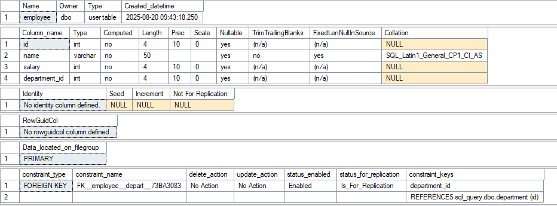
Figure 1 Employee Table
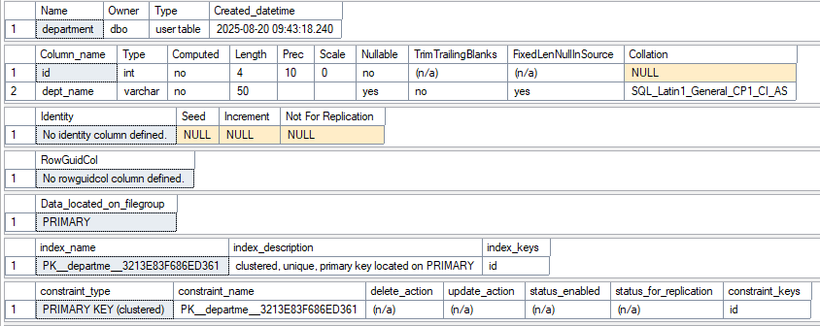
Figure 2 Department Table
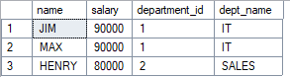
Figure 3 Output

Learning Outcomes:
  - I learned how to perform join with the subquery.
  - I understood how the subqueries actually work.
  - I learnt how different joins works with subquery.

HARD - LEVEL
- Problem Title: Merging Employee Histories: Who Earned Least?
- Problem Description: Two legacy HR systems (A and B) have separate records of employee salaries. These records may overlap. Management wants to merge these datasets and identify each unique employee (by EmpID) along with their lowest recorded salary across both systems. Objective:
  - Combine two tables A and B.
  - Return each EmpID with their lowest salary, and the corresponding Ename.

SQL Commands:
  - Create the tables.
create table A(
id int,
ename varchar(5),
salary int); create table B(
id int,
ename varchar(5),
salary int); insert into A values (1,'AA',1000),
(2,'BB',300);
insert into B values (2,'BB',400),
(3,'CC',100);

  - Use a subquery get the enames with min salary.
select id, ename, Min(salary) as salary from (
select id, ename, salary from A
union
select id, ename, salary from B
) as combined
group by id, ename;

Output:
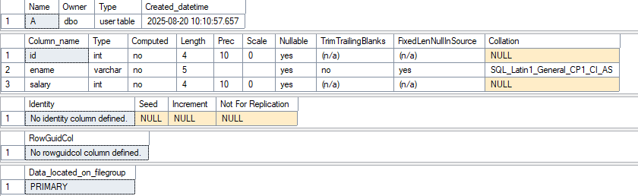
Figure 1 A table

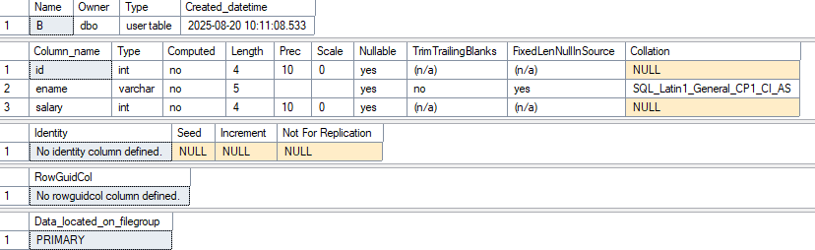
Figure 2 B table
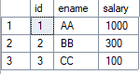
Figure 3 Output

Learning Outcomes:
  - I learned how to perform union with the subquery.
  - I learned some of the build functions of the Microsoft SQL server.
  - I learned about aliases in the SQL queries.

